**Step1: Authentication, Sign Up and Sign In**

**(Skeleton view: need to improve in UI and database)**

**Key Points:**

* Start application(Login page)

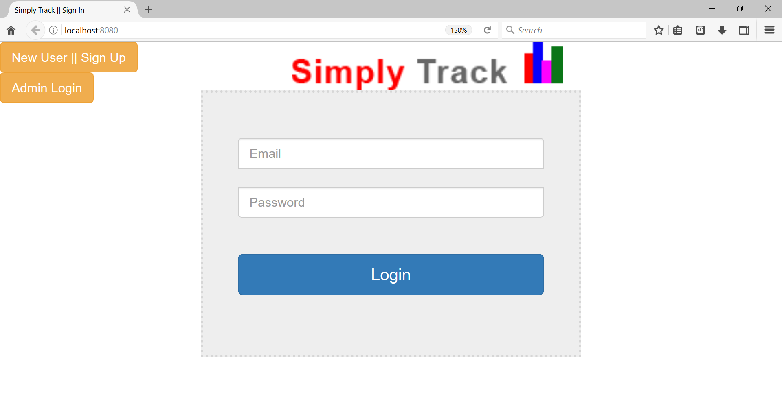

* If new user, need to Sign up **(Note: will be update with more input fields)**

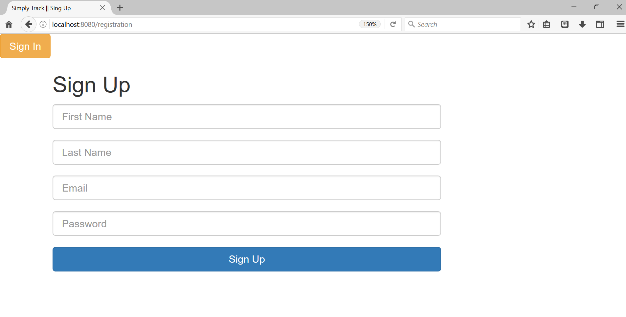

* Existing user: Login in to app using user id(email) and password

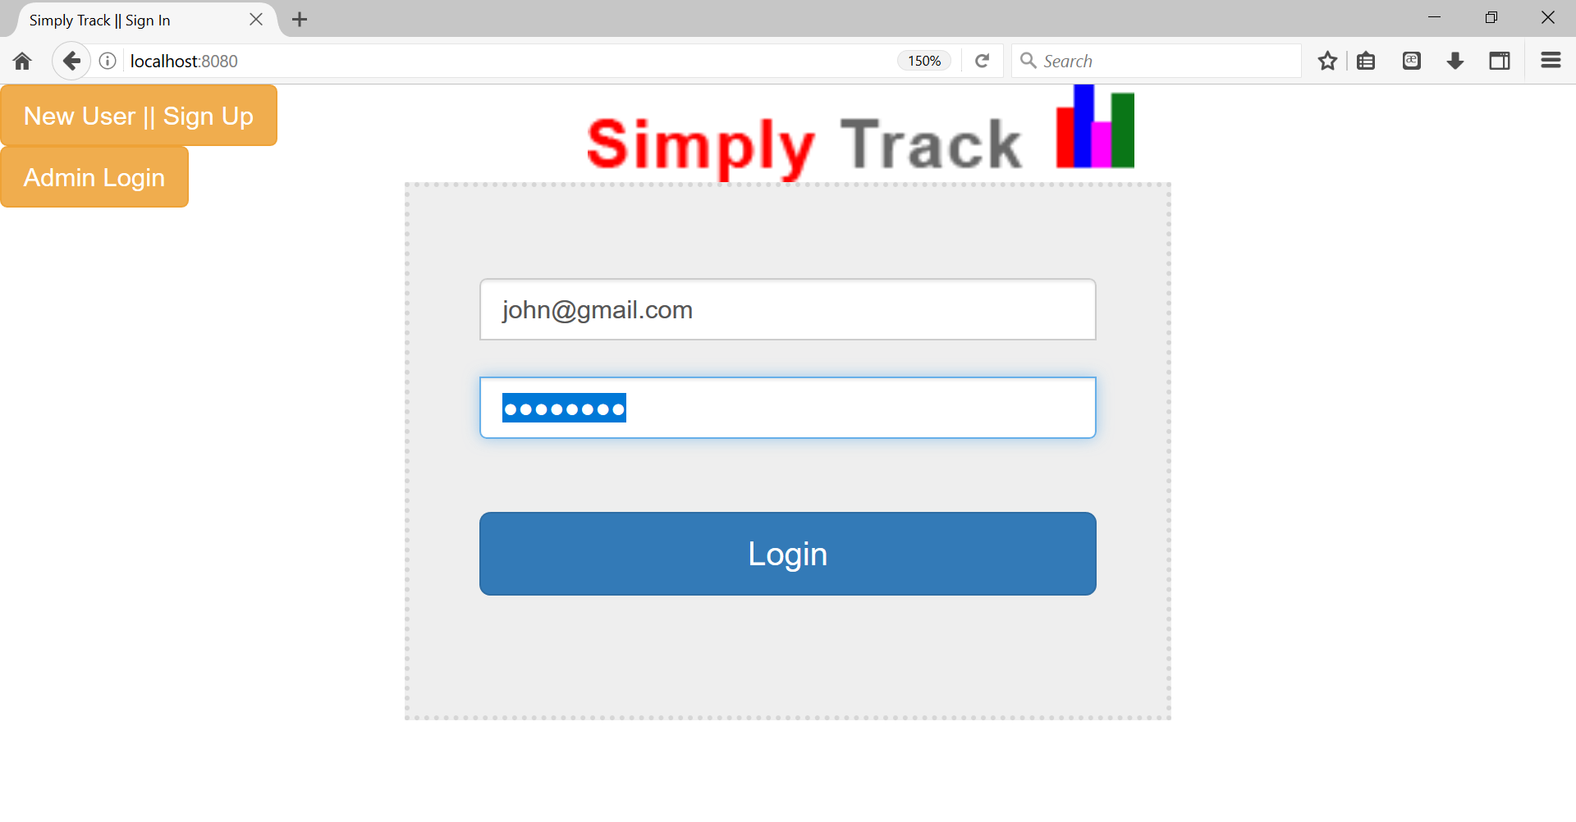

* Home page(need to update UI (navigation bar with more info)

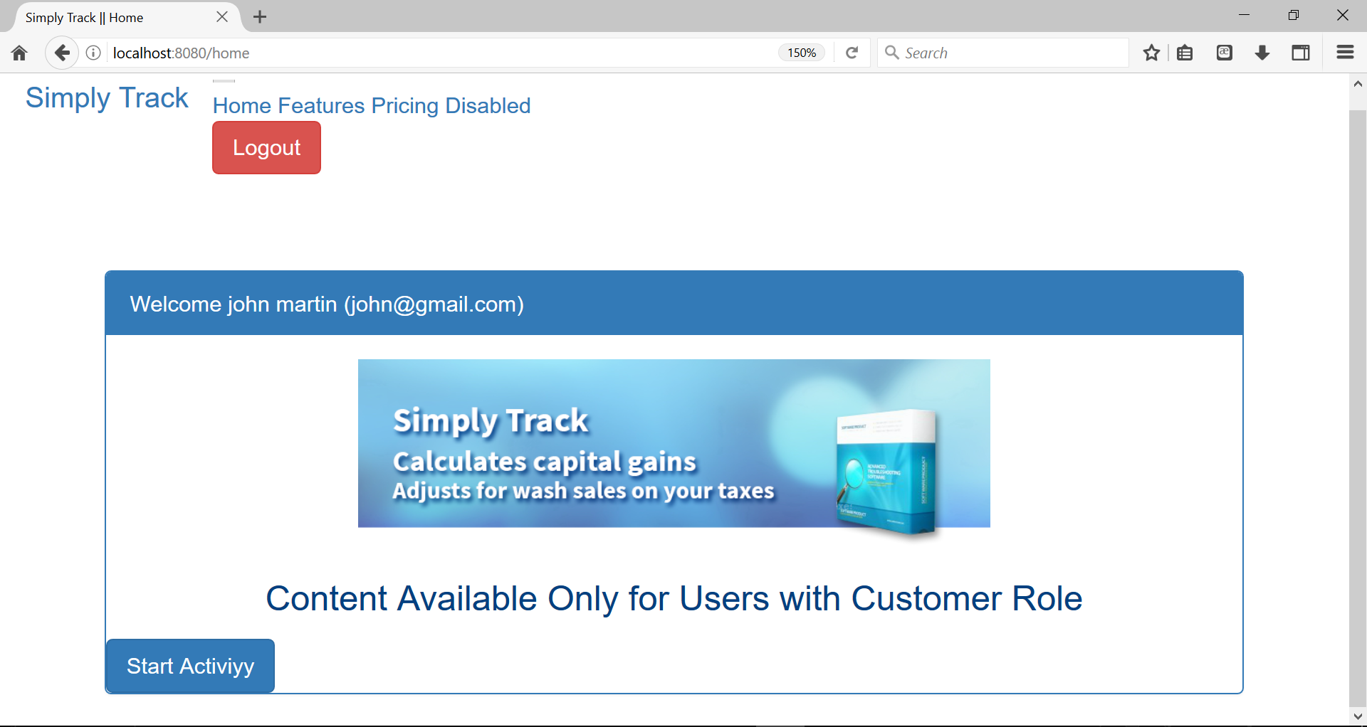

* Start Activity: starting step to enter

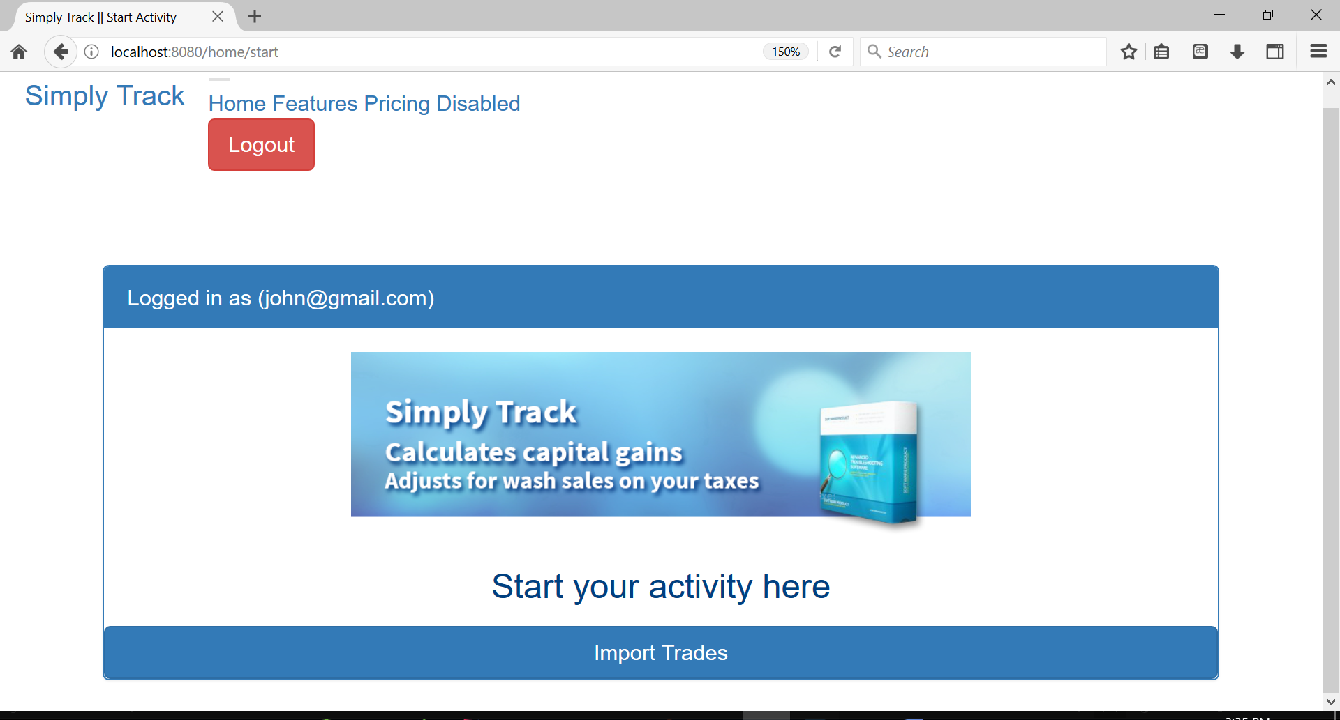

* Logout: Logout from our app securely.

**Technical Info:**

**Application Type:** Spring Boot MVC Web Application

**Design patterns:** MVC, REST, DAO, Factory, POM

**Programming language:** Java

**Framework:** Spring (Spring Boot)

**Spring Modules:** Spring Boot Security, Spring Boot REST API, Spring Boot JPA

**Build Tool:** Maven

**Database:** MySQL

**Logging:** Log4j

**Unit Testing:** Junit and Mockito

**Front end tools:** HTML(5), CSS(3), Bootstrap, JQuery

**Template Engine:** Thymeleaf

**Server:** Tomcat

**Deployment:** AWS EC2 or PCF

**IDE:** STS (Spring Tool Suite)

**Data Model: DB Tables (three main tables for login activity)**

1. **Role**

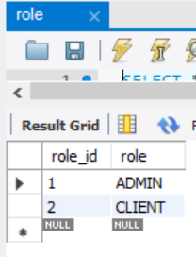

1. **User_role:**

**role_id:1 >> admin**

**role_id:2 >> customer/client**

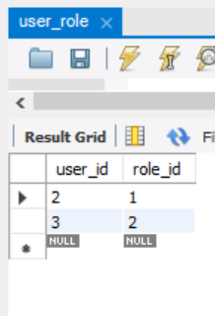

1. **User table**

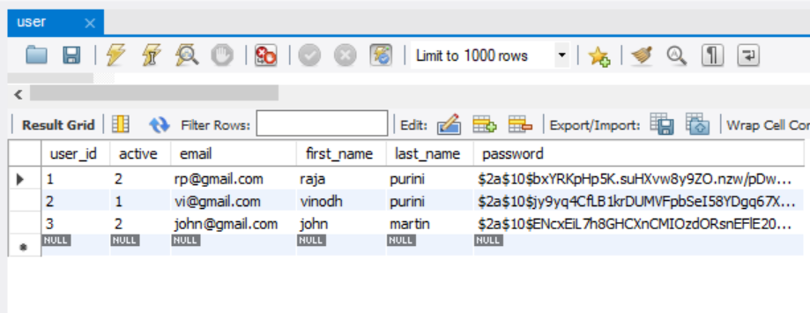

**Password: will be encrypted (spring boot security)**